 **BAHRIA UNIVERSITY (KARACHI CAMPUS)**

**Open Ended Lab# 1 - FALL 2020**

# Operating Systems (CSC-320)

Class: **BSE 4 B** Submission Deadline: **23/04 March, 2020**

Reg. No. **57285** Course Instructor: **Dr. Osama Rehman**

**Student’s Name:** **Syed Ali Abbas** Lab Instructor: **Engr. Fareeha Dilawar**

**Enrollment No. 02-131182-070** Max Marks: **15**

**OPERATING SYSTEMS LAB CSC-320**

**OPEN ENDED LAB – I**

**BSE-4B**

**Max Marks = 15**

**Deadline: 23 April 2020 11:59 PM**

**Task 1:** Write a shell script to check whether a number is prime number or not and save this script as a separate file. Copy this script in a new file followed by removing the original file. Then create another shell script and write a program to check whether a character is vowel or not. Create a third shell script which takes input from the user on which program from the previous two (i.e. prime number and vowel checker) should it execute. According the user’s input, the selected program should be executed. **[CLO#2, 4.0 Marks]**

**Prime Number:**

**Input:**

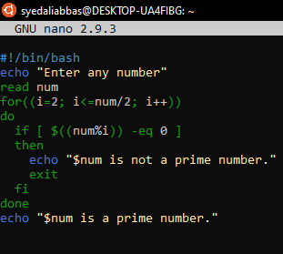

**Check directory “prime.sh” file is being created**



**Output:**

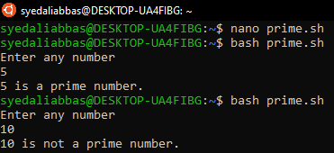

Command For copying **“prime.sh”** file code in **“newprime.sh”** and file **Removing “prime.sh”** using pipe

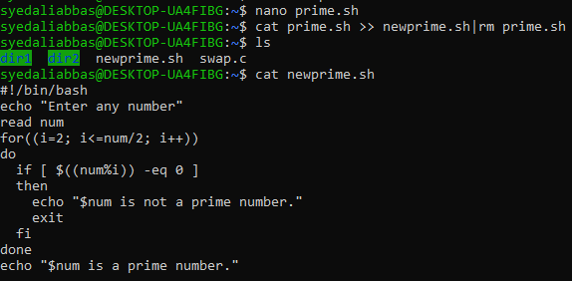

Check Directory “**prime.sh”** is removed and **“newprime.sh”** is created



**Compare it contains the same code as was in prime.sh**



**Output of newprime.sh:**

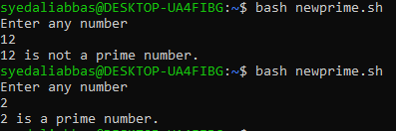

**Vowel Or Not Vowel:**

**Input:**

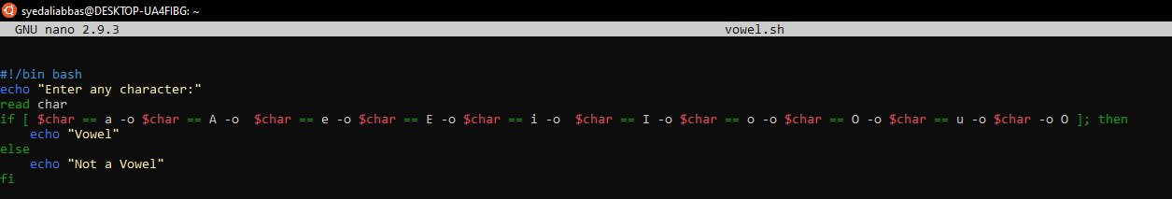

**Output:**

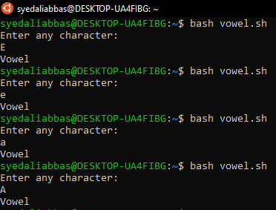

**Merge Two Files:**

**Both files are merged here means using if else you can run any file i.e. vowel.sh and newprime.sh file**

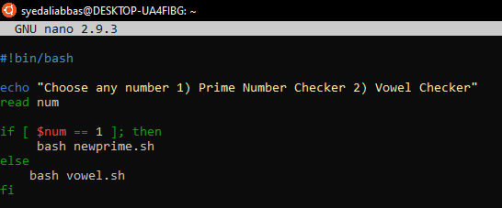

**Output: select 1 for prime number check and 2 for vowel check**

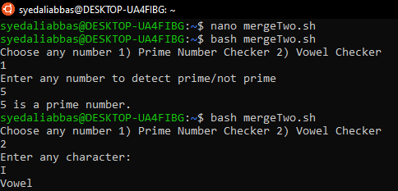

**Task 2:** Write a C program to display sum of all natural numbers between 1-100 whose sum is a prime number. The output should be displayed in descending order. The task should be executed eight times and each time a process ID should be generated. **[CLO#2, 4.0 Marks]**

**Input:**

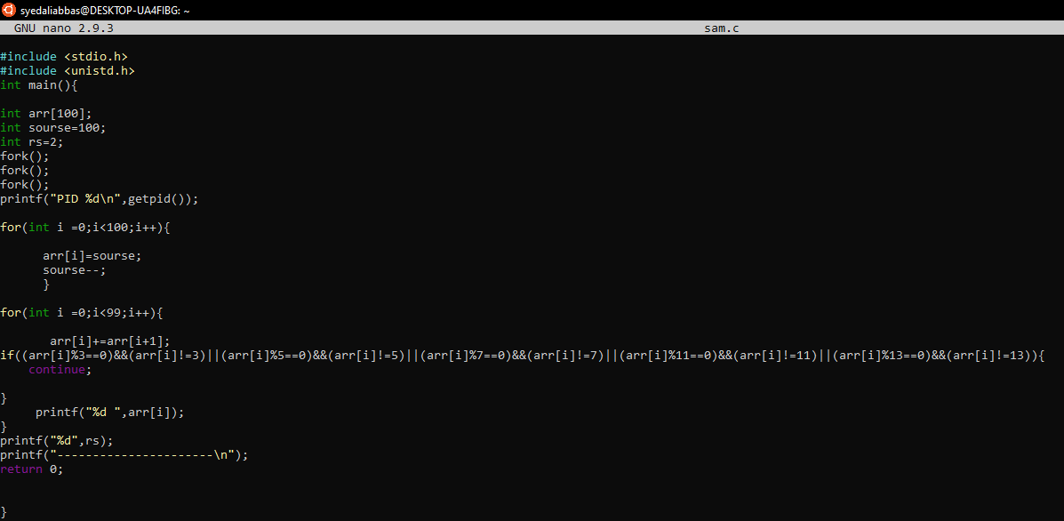

**Output:**

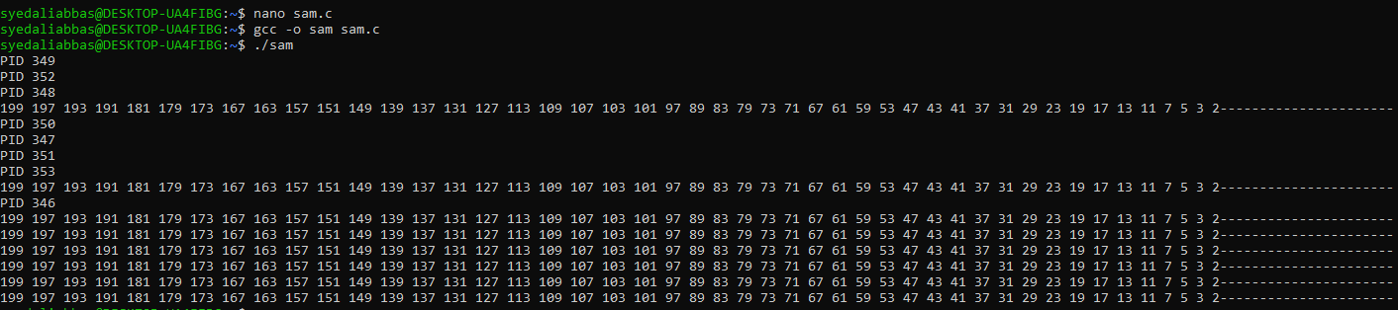

**Task 3:** Find contents of one file and display the search results in a second file. Also, display the total word count and line count in the file and all this should be displayed sorted in the second file. All this should be done using a single command. **[CLO#2, 3.0 Marks]**

**Input:**



**First File is sorted:**

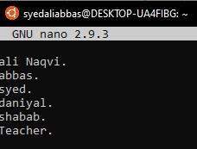

**Second File is also sorted**

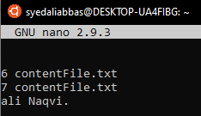

**Note**

* Number of words in first file are 7
* Number if lines in First File are 6
* I searched Naqvi and it displayed Ali Naqvi

**Task 4:** By using C- language, swap five numbers in cyclic form. The output for three number cyclic swap is as below, similarly do it for five numbers and the output should also be displayed in the same form.

Value before swapping:

a = 1

b = 2

c = 3

Value after swapping:

a = 3

b = 1

c = 2

**[CLO#2, 4.0 Marks]**

**Input:**

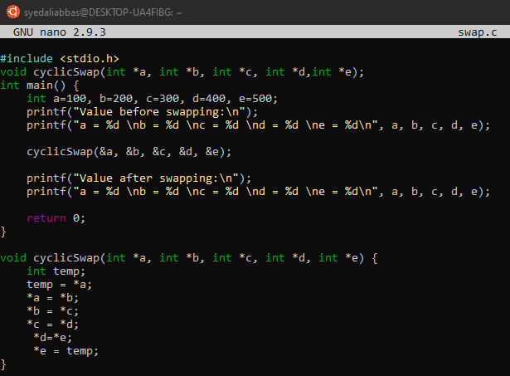

**Output**

